A

MAJOR PROJECT REPORT
(SYNOPSIS)

ON

“CUSTOMER CHURN PREDICTION AND LIFETIME VALUE ESTIMATION”



This Project Report is submitted to

Rajiv Gandhi Proudyogiki Vishwavidyalaya

in the partial fulfillment for the award of the degree of

Bachelor of Technology
VIII SEM
(Computer Science & Engg.)

Submitted By:

Riya Singh (0228cs221149)
Palak Patel (0228cs221124)

Under the guidance of:

Prof. Nitin Shukla

Head of Department

Computer Science
SHRI RAM GROUP OF INSTITUTIONS (SRGI)

SHRI RAM GROUP OF INSTITUTIONS (SRGI), JABALPUR
2026

 Approved by AICTE New Delhi & Govt. of M.P.
(Affiliated to R.G.P.V. - University of Technology of Madhya Pradesh)

CERTIFICATE
This is to certify that,

Riya Singh (Enroll No.: 0228cs221149)
Palak Patel (Enroll No.: 0228cs221124)

Students of 8th Semester, Computer Science & Engineering, SHRI RAM GROUP OF INSTITUTIONS (SRGI), Jabalpur have submitted their major project synopsis entitled “CUSTUMOR CHURN PREDICTION AND LIFETIME VALUE ESTIMATION” for the completion of 8th semester examination under the requirement for the degree of Bachelor of Technology as per R.G.P.V., Bhopal (M.P.).

This is an original work of these students and is based on their own innovative idea. We, hereby certify this project to be an authentic work by these young minds.

Prof. Nitin Shukla
Head- Computer Science Dept. S.R.G.I.


Approved by AICTE New Delhi & Govt. of M.P.
(Affiliated to R.G.P.V.- University of Technology of Madhya Pradesh)

CERTIFICATE OF APPROVAL

The foregoing major project title “ CUSTUMOR CHURN PREDICTION AND LIFETIME VALUE ESTIMATION” is hereby approved as a creditable study of an engineering subject carried out and presented in a manner satisfactory to warrant its acceptance as a prerequisite to the degree for which it has been submitted. It is understood that by this approval the undersigned do not necessarily endorse or approve any statement made, opinion expressed or conclusion drawn therein, but approve the project only for the purpose for which it has been submitted.

(Internal Examiner) (External Examiner)

 Approved by AICTE New Delhi & Govt. of M.P.
(Affiliated to R.G.P.V. - University of Technology of Madhya Pradesh)

DECLARATION

Here we declare that the project entitled which is being submitted in partial fulfillment of the requirement for the award of the degree of Bachelor of Technology in Computer Science “RAJIV GANDHI PROUDYOGIKI VISHWAVIDYALAYA, BHOPAL [M.P]” is the authentic record of my own work done under the guidance of Prof. Nitin Shukla[HOD -Computer Science Dept].
The Matter reported in this project has not been submitted earlier for the award of degree.

PLACE: JABALPUR Riya Singh (0228cs221149)
Palak Patel (0228cs221124)
DATE:

 Approved by AICTE New Delhi & Govt. of M.P.
(Affiliated to R.G.P.V. - University of Technology of Madhya Pradesh)

FORWARD

I hereby forward project title “CUSTUMOR CHURN PREDICTION AND LIFETIME VALUE ESTIMATION” which is being submitted by
Riya Singh (Enroll No.: 0228cs221149)
Palak Patel (Enroll No.: 0228cs221124)
In partial fulfillment of the requirement for the award of Degree of Bachelor of Technology in Computer Science “Rajiv Gandhi Proudyogiki Vishwavidyalaya Bhopal [M.P]”

PLACE: JABALPUR Prof. Nitin Shukla
DATE:
HOD
Computer Science & Engg. .Department
` SHRI RAM GROUP OF INSTITUTIONS (SRGI) JABALPUR [M.P]

 Approved by AICTE New Delhi & Govt. of M.P.
(Affiliated to R.G.P.V. - University of Technology of Madhya Pradesh)

ACKNOWLEDGEMENTS

We would like to extend our gratitude to all those who gave us the possibility to complete this project. We would like to thank the Department of computer science of SHRI RAM GROUP OF INSTITUTIONS (SRGI) for giving us permission to commence this project in first instance, to do the necessary research and to use departmental accessories.
We are deeply indebted to our supervisor Prof. Nitin Shukla [HOD -Computer Science Dept] whose help, simulating suggestions and encouragement helped us in all the times in completing this project.

We are bound to our honorable head of the department Prof. Nitin Shukla his simulating support. We have further more to thank the Faculty of our college who helped us in providing the necessary data.
Our former colleagues in the department also supported us in our project. We want to thank them for all their help, support, interest and valuable hints.

PLACE: JABALPUR Riya Singh (0228cs221149)
Palak Patel (0228cs221124)

DATE:

INDEX

Chapter 1 | INTRODUCTION | 1–6
 | 1.1 Introduction | 1
 | 1.2 Problem Statement | 2
 | 1.3 Project Objectives & Goals | 3
 | 1.4 Scope and Limitations | 4-5
 | 1.5 Report Outline | 6
Chapter 2 | LITERATURE SURVEY | 7-9
 | 2.1 Survey and Analysis of Existing Solutions | 7-8
 | 2.2 Identification of Research Gap | 8-9
Chapter 3 | REQUIREMENT ANALYSIS AND SPECIFICATION | 10-13
 | 3.1 Functional Requirements | 10
 | 3.2 Non-Functional Requirements | 11
 | 3.3 Software and Hardware Requirements | 12-13
Chapter 4 | SYSTEM DESIGN AND ARCHITECTURE | 14-16
 | 4.1 System Architecture Diagram | 14
 | 4.2 Database Design (Entity-Relationship Diagram, Schema) | 15
 | 4.3 Model Design (Flowcharts, Pseudocode) | 15
 | 4.4 DFD Diagrams | 16
 | 4.5 Use Case Diagrams | 16
Chapter 5 | IMPLEMENTATION, TESTING, AND MAINTENANCE | 17-19
 | 5.1 Introduction to Languages, IDE’s | 17
 | 5.2 Tools and Technologies used for Implementation | 17
 | 5.3 Coding standards of Language used Project Scheduling using various tools such as PERT, GANTT charts, Open PROJ etc. | 18
 | 5.4 Testing Techniques and Test Plans | 18-19
Chapter 6 | EXPECTED RESULTS AND DISCUSSION | 20-21
 | 6.1 Expected Results and Discussion | 20
 | 6.2 Expected Performance Results | 21
Chapter 7 | CONCLUSION | 22
 | 7.1 Conclusion | 22
APPENDICES | Appendix A: Source Code (GitHub Repository Link and Snapshot)  Appendix B: Comprehensive Project Timeline (Gantt Chart)  Appendix C: Team Member Contributions  Appendix D: Dataset Details and Sources  Appendix E: Relevant Published Papers | 23  24  25  25  26

CHAPTER 1
INTRODUCTION

1.1 INTRODUCTION
In today’s highly competitive business environment, customer retention has become one of the most important factors for organizational success. Companies invest significant resources in acquiring new customers, but retaining existing customers is more cost-effective and profitable. One of the major challenges faced by subscription-based industries such as telecommunications, banking, insurance, and e-commerce is customer churn, where customers discontinue services and move to competitors.
Customer churn directly affects company revenue, market share, and long-term growth. Therefore, organizations require intelligent systems that can identify customers who are likely to leave in advance so that proper retention strategies can be applied. At the same time, businesses also need to understand the future value of each customer in order to focus their efforts on the most profitable customers. This concept is known as Customer Lifetime Value (CLV).
The project “Customer Churn Prediction and Customer Lifetime Value Estimation System” has been developed to solve these challenges using modern data analytics and predictive technologies. The system analyzes customer-related information such as demographics, service usage, billing history, subscription details, and payment behavior to predict churn probability and estimate customer value.
The project provides a complete end-to-end solution where customer data is collected, processed, analyzed, and converted into actionable insights. It uses a Random Forest Classification Model for churn prediction and a Random Forest Regression Model for CLV estimation. The solution is further integrated with FastAPI for real-time prediction services and Streamlit Dashboard for interactive user access and reporting.
This project is especially useful for telecom companies and other service-based organizations where customer retention and revenue forecasting are critical business requirements. By using this system, companies can identify high-risk customers, reduce customer loss, improve marketing efficiency, and make data-driven business decisions.

1.2 Problem Statement
In modern organizations, large volumes of data are available from multiple sources. This data may include customer details, sales records, healthcare reports, financial transactions, educational performance records, and many other forms of information. Although data is available in abundance, extracting useful knowledge from it remains a major challenge.
Traditional manual analysis methods are slow, time-consuming, and often unable to handle complex datasets efficiently. Raw datasets usually contain several problems such as:
- Missing or incomplete values
- Duplicate records
- Noise and irrelevant information
- Inconsistent formats
- Large number of attributes
- Unstructured data patterns
Due to these issues, it becomes difficult for organizations to make fast and accurate decisions. Therefore, an intelligent system is required that can automatically process data, clean it, analyze it, and generate reliable predictions.
The main problem addressed in this project is to create a Machine Learning-based solution that can:
- Accept raw dataset input.
- Preprocess and clean the data.
- Analyze patterns and relationships within the dataset.
- Train predictive models using machine learning algorithms.
- Evaluate model performance and accuracy.
- Provide meaningful predictions or classifications.
This project aims to solve the challenge of converting raw data into useful knowledge and helping users make better decisions based on data-driven results.

1.3 Project Objectives & Goals
The primary objective of the ML Fundamentals Assignment is to understand the core principles of Machine Learning and implement them practically using real datasets. The detailed objectives and goals of the project are as follows:
1. To Understand Basic Concepts of Machine Learning
The project helps in understanding supervised learning, unsupervised learning, model training, testing, prediction, and evaluation techniques.
2. To Collect and Prepare Data
Data is the foundation of any ML system. This objective focuses on loading datasets, understanding attributes, checking data types, and preparing structured input for further analysis.
3. To Perform Data Cleaning
Raw datasets often contain errors and missing values. The goal is to clean the dataset by removing duplicates, handling null values, and correcting inconsistencies.
4. To Conduct Exploratory Data Analysis (EDA)
EDA helps in understanding trends, distributions, correlations, and hidden relationships in the dataset through tables, graphs, and charts.
5. To Apply Feature Engineering
Feature engineering involves selecting useful variables, transforming categorical values, scaling data, and improving the quality of input features.
6. To Train Machine Learning Models
The project aims to apply suitable algorithms such as Linear Regression, Logistic Regression, Decision Tree, KNN, or other basic models depending on dataset requirements.
7. To Test and Evaluate Performance
The performance of models is measured using metrics such as:
- Accuracy
- Precision
- Recall
- F1-score
- Mean Squared Error
- Confusion Matrix
8. To Compare Multiple Models
Different models may perform differently on the same dataset. The objective is to compare results and identify the most efficient algorithm.

9. To Gain Practical Experience
The project gives practical knowledge of Python tools, coding structure, data visualization, and ML workflow implementation.

10. To Build Foundation for Advanced Learning
This project creates a strong base for learning advanced AI technologies such as Deep Learning, Neural Networks, NLP, and Big Data Analytics.

1.4 Scope and Limitations
Scope
The scope of this project is broad because Machine Learning techniques can be applied in many domains. This project provides a starting point for practical implementation and future expansion.
1. Educational Scope
The project is highly useful for students who want to learn the real implementation of machine learning concepts beyond theoretical study.
2. Industrial Scope
The same techniques can be used in industries for:
- Customer churn prediction
- Sales forecasting
- Fraud detection
- Product recommendation
- Risk analysis
- Employee performance analysis
3. Research Scope
The project can be extended by using advanced datasets, tuning parameters, and testing newer algorithms.
4. Technological Scope
It can be integrated with web applications, mobile apps, dashboards, and cloud-based systems for real-time predictions.
5. Future Scope
The project can later include:
- Deep Learning models
- Image processing
- Chatbots
- Natural Language Processing
- Real-time automation systems

Limitations
Although the project is useful, certain limitations exist:
1. Dataset Dependency
The quality of output depends entirely on the quality, size, and relevance of the dataset.
2. Limited Accuracy
Basic algorithms may not always provide high accuracy for complex real-world problems.

3. Computational Resources
Some machine learning models require high RAM, CPU, or GPU resources.
4. Overfitting and Underfitting
Improper training may cause models to memorize data or fail to learn patterns.

5. Time Consumption
Data preprocessing, training, and tuning may take significant time for large datasets.

6. Fundamental Level Project
This project mainly focuses on ML fundamentals and may not include enterprise-level deployment features.

1.5 Report Outline

The project report has been organized into different chapters to provide systematic understanding and easy navigation.
Chapter 1: Introduction
This chapter gives an overview of the project, problem statement, objectives, scope, limitations, and report structure.

Chapter 2: Literature Review
This chapter discusses previous studies, existing technologies, machine learning concepts, and related work in the field.

Chapter 3: System Analysis and Design
This chapter explains system requirements, tools used, dataset description, architecture, methodology, flowcharts, and design structure.

Chapter 4: Implementation
This chapter includes coding details, software environment, preprocessing steps, feature selection, model training, and execution process.

Chapter 5: Results and Discussion
This chapter presents outputs, graphs, evaluation metrics, comparisons, observations, and interpretation of results.

Chapter 6: Conclusion and Future Scope
This chapter summarizes the complete project, achievements, challenges, and future enhancements.

Chapter 7: References
This chapter contains books, research papers, websites, and resources used during project development.

CHAPTER 2

LITERATURE SURVEY

2.1 Survey and Analysis of Existing Solutions

Machine Learning based customer analytics solutions have become highly important in industries such as telecommunications, banking, healthcare, insurance, and e-commerce. Organizations generate large amounts of customer data related to usage behavior, billing patterns, subscriptions, complaints, and service history. Traditional business methods are no longer sufficient to analyze this data efficiently. Therefore, many companies are adopting Machine Learning solutions for customer churn prediction, customer segmentation, and revenue forecasting.
The present project focuses on Customer Churn Prediction and Customer Lifetime Value (CLV) Estimation using Machine Learning techniques. Before developing this system, several existing solutions and approaches were studied.

1. Rule-Based Existing Systems
Many organizations previously used manual and rule-based systems for identifying customers likely to leave services. These systems depended on fixed conditions such as:
- Low recharge frequency
- Late bill payments
- Reduced service usage
- Frequent complaints
Although simple to implement, rule-based systems have several drawbacks:
- Low prediction accuracy
- Inability to detect hidden patterns
- Static rules with no learning capability
- Poor scalability for large datasets

2. Statistical and Traditional Models
Some companies use statistical techniques such as:
- Linear Regression
- Logistic Regression
- Probability Scoring Models
- Correlation Analysis
These methods are useful for basic forecasting and classification problems. However, they often struggle when datasets become complex, nonlinear, or contain multiple interacting variables.

3. Machine Learning Based Existing Solutions
Modern organizations use Machine Learning algorithms for churn prediction and customer behavior analysis. Commonly used algorithms include:
- Decision Tree
- Random Forest
- Support Vector Machine (SVM)
- K-Nearest Neighbors (KNN)
- Gradient Boosting
- Neural Networks
These models provide better prediction accuracy because they learn patterns from historical customer data.
For churn prediction, classification algorithms are generally used. For CLV estimation, regression algorithms are preferred.

4. Existing Deployment Solutions
Modern Machine Learning systems are not limited to model training only. Many organizations deploy models using:
- REST APIs
- FastAPI / Flask
- Docker Containers
- Cloud Platforms such as AWS, Azure, GCP
- Web Dashboards using Streamlit or Power BI
This allows real-time prediction and business decision support.

5. Existing Visualization and Reporting Solutions
For stakeholder understanding, dashboards are commonly developed to display:
- Churn risk percentages
- Revenue forecasts
- Customer segmentation reports
- Performance metrics
- Graphical insights

2.2 Identification of Research Gap

After studying existing systems and available solutions, several important research gaps were identified.

- Lack of Integrated Dual Prediction Systems
Many existing systems focus only on customer churn prediction or only on revenue estimation. Very few systems combine both churn risk prediction and Customer Lifetime Value estimation in a single platform.
This project solves that gap by providing both:
- Churn Probability Prediction
- Customer Lifetime Value Prediction

- Limited Real-Time Deployment
Many academic projects stop after training the model and do not provide real-time deployment.
Missing areas include:
- API integration
- Real-time prediction services
- Containerized deployment
- User dashboards
This project addresses these limitations using FastAPI, Docker, and Streamlit.

- Poor Explainability for Business Users
Some high-accuracy systems are difficult for business teams to understand. Stakeholders need simple dashboards and meaningful outputs rather than raw model data.
This project fills that gap through a user-friendly web interface and easy-to-read prediction results.

- Incomplete End-to-End Workflow
Several beginner Machine Learning projects only focus on algorithms and ignore critical steps such as:
- Data preprocessing
- Feature engineering
- Model validation
- Deployment
- Performance monitoring
This project covers the complete Machine Learning lifecycle.

5. Scalability Challenges
Traditional churn systems may fail with large user data or concurrent requests.
This project uses:
- Docker containers
- Microservice architecture
- Cloud deployment readiness
to solve scalability issues.

6. Gap Between Theory and Industry Practice
Many students learn Machine Learning theoretically but lack understanding of production deployment.
This project bridges that gap by combining:
- Machine Learning model development
- API creation
- Dashboard development
- Cloud-ready deployment
- Business impact analysis

CHAPTER 3

REQUIREMENT ANALYSIS AND SPECIFICATION

3.1 Functional Requirements
Functional requirements define the major operations and services that the proposed system must perform. The project Customer Churn Prediction and Customer Lifetime Value (CLV) Estimation System is designed to analyze customer data, predict churn risk, estimate lifetime value, and provide real-time business insights.
The main functional requirements of the system are as follows:

1. Data Input and Upload Module
The system should allow users to upload customer datasets in supported formats such as:
- CSV files
- Excel files
- Database records (future scope)
The uploaded data may contain customer demographic details, billing records, usage history, subscription information, and payment behavior.

2. Data Preprocessing Module
The system should automatically preprocess raw data before prediction. This includes:
- Handling missing values
- Removing duplicate records
- Correcting inconsistent values
- Encoding categorical attributes
- Feature scaling and normalization
- Data transformation
This ensures high-quality input for machine learning models.

3. Customer Churn Prediction Module
The system should analyze processed customer data and predict whether a customer is likely to churn or remain active.
Expected outputs:
- Churn / No Churn result
- Churn probability score
- Risk category (Low / Medium / High)

4. Customer Lifetime Value Estimation Module
The system should estimate the future value of each customer using regression models.
Expected outputs:
- Predicted customer lifetime value
- Revenue contribution estimate
- Priority customer identification

5. Model Evaluation Module
The system should evaluate model performance using metrics such as:
- Accuracy
- Precision
- Recall
- F1 Score
- R² Score
- MAE / RMSE

6. API Service Module
The system should provide REST API endpoints for external integration such as:
- CRM systems
- Web applications
- Business tools
- Future AI agents

7. User Interface Module
The system should provide an interactive dashboard through Streamlit where users can:
- Upload data
- View predictions
- Analyze metrics
- Explore graphs and reports

8. Report Generation Module
The system should allow downloading outputs and prediction reports for business use.

9. Admin and Monitoring Module
The system should monitor:
- API health status
- Response time
- Error logs
- Prediction requests

3.2 Non-Functional Requirements

Non-functional requirements define the quality attributes, performance standards, and operational expectations of the system.

1. Performance Requirement
The system should generate predictions quickly with low latency.
- Average API response time should be near real-time.
- Bulk dataset processing should be efficient.

2. Accuracy Requirement
The machine learning models should provide high predictive accuracy.
- Churn model should maintain strong classification performance.
- CLV model should provide reliable regression outputs.

3. Scalability Requirement
The system should support increasing user requests and larger datasets through containerized deployment.

4. Reliability Requirement
The application should operate continuously with minimum downtime and stable predictions.

5. Usability Requirement
The system should be easy to use for technical and non-technical users through a simple dashboard interface.

6. Security Requirement
The system should protect uploaded data and API access using:
- Authentication mechanisms
- Secure communication (HTTPS)
- Access control

7. Maintainability Requirement
The system should be modular so that future updates, retraining, and feature additions can be done easily.

8. Portability Requirement
The project should run on different environments such as:
- Local computer
- Cloud server
- Docker container
- Linux / Windows systems

3.3 Software and Hardware Requirements

Software Requirements
The software required to develop and run the project includes:
- Operating System: Windows, Linux, or macOS
- Programming Language: Python 3.x
- Code Editor / IDE: Visual Studio Code, PyCharm, or Jupyter Notebook
- Data Processing Libraries: Pandas and NumPy
- Machine Learning Library: Scikit-learn
- Visualization Libraries: Matplotlib, Seaborn, Plotly
- Web Interface Framework: Streamlit
- API Framework: FastAPI
- Containerization Tool: Docker
- Version Control: Git and GitHub
Hardware Requirements
The minimum hardware required for the project includes:
- Processor: Intel i5 / Ryzen 5 or above
- RAM: Minimum 8 GB
- Storage: 256 GB SSD or above
- Internet Connection: Required for deployment and repository access
- GPU: Optional for advanced future models

CHAPTER 4

SYSTEM DESIGN AND ARCHITECTURE

4.1 System Architecture Diagram
The proposed Customer Churn Prediction and Customer Lifetime Value (CLV) Estimation System follows a modular architecture where data is collected, processed, analyzed through machine learning models, and presented to users through an interactive dashboard.

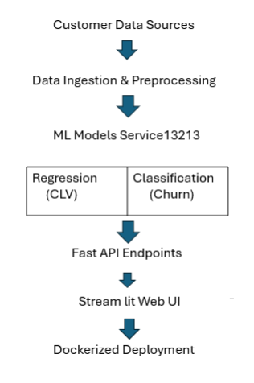
4.2 Database Design (Entity-Relationship Diagram, Schema)
The system stores customer details, prediction results, uploaded datasets, and user records.

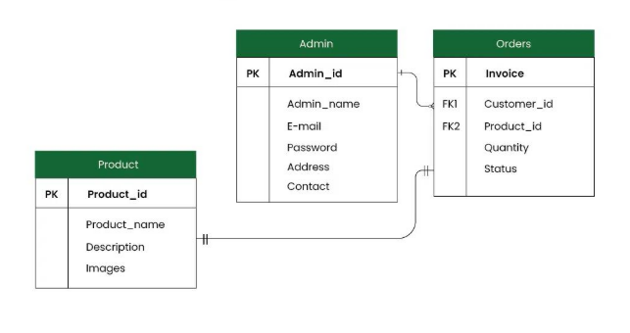

4.3 Model Design (Flowcharts, Pseudocode)
The machine learning workflow starts with data input, preprocessing, model training, testing, and prediction generation.

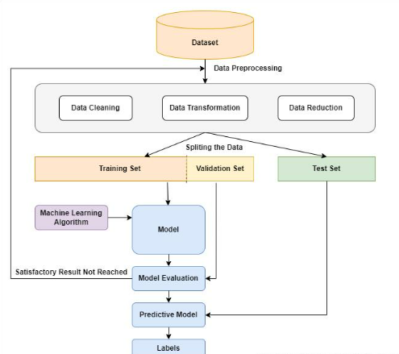
4.4 DFD Diagrams
Data Flow Diagram explains movement of data between user, system, models, and reports.

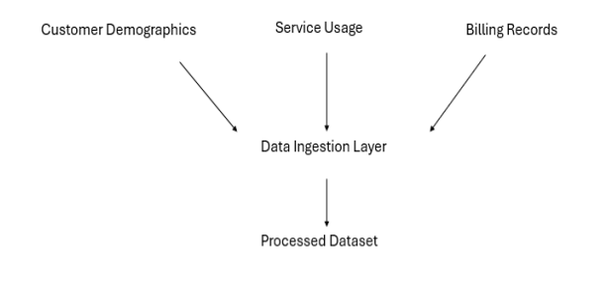

4.5 Use Case Diagrams
Use Case Diagrams represent the interaction between users and the Customer Churn Prediction and CLV Estimation System. They show what operations different users can perform in the system.

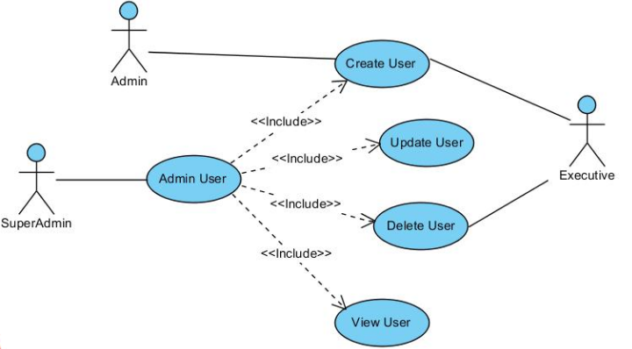
CHAPTER 5

IMPLEMENTATION, TESTING, AND MAINTENANCE

5.1 Introduction to Languages, IDE’s
Implementation is one of the most important phases of the project where the designed into a working software solution. In this project, modern programming languages and development environments were used to build an efficient Customer Churn Prediction and Customer Lifetime Value (CLV) Estimation System.

Programming Languages Used
1. Python
Python is the main programming language used in this project. It is widely used in Machine Learning because of its simple syntax, rich libraries, and strong community support.
Uses in Project:
- Data preprocessing
- Model training system is converted
- Prediction system
- API development
- Dashboard creation
2. SQL
SQL is used for storing customer data, prediction logs, and reports in databases.

IDEs / Development Environments Used
1. Visual Studio Code
Used for coding, debugging, project management, and API development.

2. Jupyter Notebook
Used for:
- Data analysis
- Exploratory Data Analysis (EDA)
- Model experimentation
- Visualization

5.2 Tools and Technologies used for Implementation
Various tools and technologies were used for successful implementation of the project.

Machine Learning Libraries
- Pandas – Data manipulation
- NumPy – Numerical operations
- Scikit-learn – Model development
- Matplotlib – Graphs and charts
- Seaborn – Statistical visualization

Web & API Tools
- Streamlit – Interactive web dashboard
- FastAPI – REST API services

Deployment Tools
- Docker – Containerization
- GitHub – Version control
- AWS – Cloud deployment support

Supporting Tools
- Excel / CSV – Dataset storage
- Postman – API testing
- Git – Source control

5.3 Coding Standards of Language used / Project Scheduling using PERT, GANTT Charts

Coding Standards Followed
To maintain readable and maintainable code, proper coding standards were followed.
Python Coding Standards:
- Proper indentation (PEP8 standard)
- Meaningful variable names
- Modular functions and reusable code
- Comments for complex logic
- Exception handling
- Separate files for models, API, and UI
- Clean folder structure
5.4 Testing Techniques and Test Plans

Testing ensures that the system works correctly, accurately, and reliably.
Testing Techniques Used

1. Unit Testing
Individual modules such as preprocessing, prediction, and API endpoints were tested separately.

2. Integration Testing
Checked interaction between:
- Streamlit UI and FastAPI
- API and ML models
- Input files and prediction engine

3. System Testing
Entire application tested as a complete working system.

4. Performance Testing
Measured:
- API response time
- Concurrent requests
- Resource usage

5. Accuracy Testing
Machine learning models were tested using:
- Accuracy
- Precision
- Recall
- F1 Score
- R² Score

CHAPTER 6

EXPECTED RESULTS AND DISCUSSION

6.1 Expected Results and Discussion
The proposed Customer Churn Prediction and Customer Lifetime Value (CLV) Estimation System is expected to provide accurate, fast, and meaningful business insights using Machine Learning techniques. The system is designed to analyze customer behavior, identify potential churn customers, and estimate the future value of customers for better decision-making.
After successful implementation, the system is expected to generate the following results:

1. Accurate Customer Churn Prediction
The system will classify customers into two categories:
- Likely to Churn
- Likely to Stay
This helps organizations identify at-risk customers in advance and take preventive retention actions such as offers, discounts, or personalized support.

2. Customer Lifetime Value Estimation
The system will estimate the expected future revenue generated by each customer. This helps management identify valuable customers and prioritize business strategies accordingly.

3. Better Customer Retention Strategy
By combining churn prediction and CLV estimation, the company can focus on customers who are both high-value and high-risk. This improves marketing efficiency and reduces revenue loss.

4. Real-Time Prediction Capability
Using FastAPI and Streamlit integration, the system is expected to provide instant predictions when new customer data is uploaded or entered manually.

5. Data Visualization and Reporting
The dashboard is expected to display:
- Churn probability charts
- Customer segmentation graphs
- CLV distribution reports
- Accuracy comparison charts
- Monthly retention insights

6. Improved Business Decisions
Management can use prediction outputs for:
- Customer retention campaigns
- Resource planning
- Revenue forecasting

Discussion
Traditional churn management methods are reactive, meaning companies act after losing customers. The proposed system changes this approach to proactive management by predicting churn before it happens.
The dual-model design (classification + regression) makes the system more useful than ordinary churn-only systems. It not only predicts who may leave, but also tells which customer is financially important.
6.2 Expected Performance Results
The project is expected to deliver strong model performance and efficient system response based on selected algorithms and deployment design.
1. Classification Model Performance (Churn Prediction)
Expected results using Random Forest Classifier:
- Accuracy: Around 95%
- Precision: Around 93%
- Recall: Around 92%
- F1 Score: Around 92%
- AUC Score: High predictive capability
These metrics indicate reliable churn identification with fewer false predictions.
2. Regression Model Performance (CLV Estimation)
Expected results using Random Forest Regressor:
- R² Score: Around 0.91
- Mean Absolute Error (MAE): Low error range
- RMSE: Acceptable prediction variance
- Stable output on test data
This indicates accurate customer value estimation.
This makes the system valuable for telecom companies and other subscription-based businesses.

CHAPTER 7

CONCLUSION

7.1 Conclusion
The project Customer Churn Prediction and Customer Lifetime Value (CLV) Estimation System presents an effective and intelligent solution for modern customer analytics using Machine Learning techniques. In highly competitive industries such as telecommunications, retaining valuable customers and reducing churn are essential for sustained growth and profitability. The developed system addresses these challenges by providing accurate predictions, meaningful insights, and data-driven support for strategic decision-making.
The proposed solution successfully integrates two important analytical models within a single platform. The Customer Churn Prediction model identifies customers who are likely to discontinue services, while the Customer Lifetime Value model estimates the future revenue contribution of each customer. This dual-model approach enables organizations to focus retention efforts on customers who are both high-risk and high-value, thereby maximizing business impact.
The project also demonstrates the practical implementation of the complete Machine Learning lifecycle, including:
- Data collection and preprocessing
- Feature engineering and selection
- Model training and evaluation
- API development using FastAPI
- Interactive dashboard development using Streamlit
- Containerized deployment using Docker
- Cloud-ready scalable architecture
The use of modern tools and technologies ensures that the system is efficient, reliable, maintainable, and suitable for real-world deployment. Through automation and predictive intelligence, the project can help organizations reduce customer loss, optimize marketing expenditure, improve customer satisfaction, and enhance revenue forecasting.
Another important achievement of this project is bridging the gap between academic concepts and industrial implementation. It transforms theoretical Machine Learning knowledge into a practical business solution with measurable outcomes.
In future, the system can be enhanced by integrating advanced Deep Learning models, real-time streaming analytics, automated model retraining, AI-based recommendation engines, and enterprise CRM integration.

APPENDICES

Appendix A: Source Code (GitHub Repository Link and Snapshot)
The complete source code of the project is available on GitHub repository:
Repository Link:
https://github.com/Riyasingh22600/ml-fundamentals-assignment

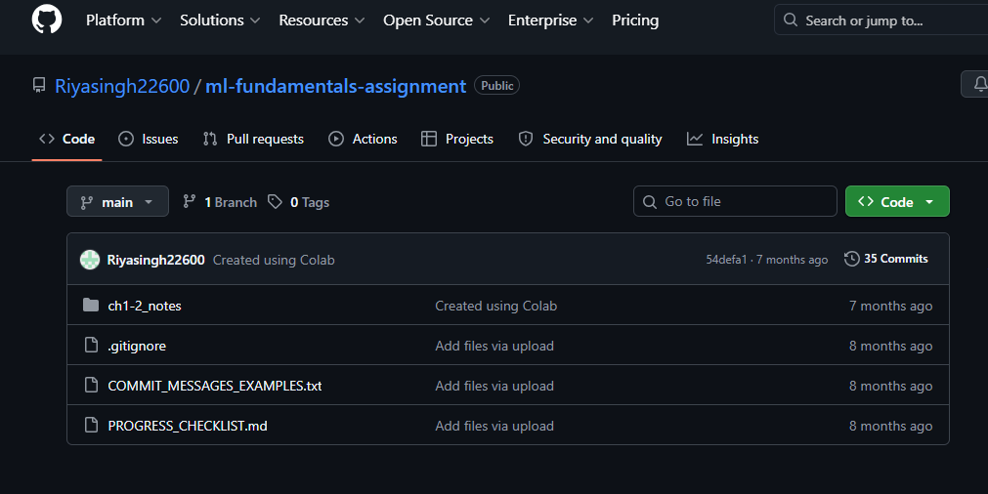

The repository contains:
- Machine Learning model implementation
- Data preprocessing scripts
- Exploratory Data Analysis notebooks
- Prediction modules
- Project documentation
- Supporting datasets and files

Appendix B: Comprehensive Project Timeline (Gantt Chart)

The project was executed in a systematic manner by dividing the complete work into multiple phases. Proper scheduling helped in timely completion of development, testing, and documentation activities.

Project Phases:
- Requirement Analysis
- Dataset Collection
- Data Preprocessing
- Exploratory Data Analysis
- Feature Engineering
- Model Development
- API Development
- Dashboard Development
- Testing and Validation
- Deployment
- Documentation

Activity | Week 1 | Week 2 | Week 3 | Week 4 | Week 5 | Week 6
Requirement Analysis | ███
Dataset Collection |  | ███
Data Cleaning & Preprocessing |  | ███ | ███
Exploratory Data Analysis |  |  | ███
Feature Engineering |  |  | ███ | ███
Model Development |  |  |  | ███ | ███
API Development |  |  |  | ███ | ███
Dashboard Development |  |  |  |  | ███ | ███
Testing & Validation |  |  |  |  | ███ | ███
Deployment |  |  |  |  |  | ███
Documentation |  |  |  |  |  | ███

Appendix C: Team Member Contributions

The project was completed through collaborative efforts where each team member contributed to different modules. Proper division of responsibilities helped in smooth execution, timely completion, and successful implementation of the project.
1. Riya Singh
- Requirement analysis and project planning
- Dataset collection and preprocessing
- Exploratory Data Analysis (EDA)
- Machine Learning model training and evaluation
- Customer churn prediction module development
- Testing and validation of model results
- Documentation and report writing
- GitHub repository management
- Final presentation preparation
- Review and formatting of documentation

2. Palak Patel
- Customer Lifetime Value (CLV) module support
- FastAPI backend integration
- Streamlit dashboard development
- User interface design and data visualization
- API testing and debugging
- Deployment support using Docker / cloud environment

Appendix D: Dataset Details and Sources

The dataset used in this project contains telecom customer-related information required for churn prediction and customer value estimation.
Dataset Features:
- Customer ID
- Gender
- Age
- Tenure
- Monthly Charges
- Total Charges
- Contract Type
- Internet Service
- Payment Method
- Subscription Details
- Churn Status
Dataset Characteristics:
- Structured tabular dataset
- Numerical and categorical attributes
- Suitable for classification and regression tasks
- Cleaned and preprocessed before training
Sources of Dataset:
- Telecom customer records
- Publicly available churn datasets
- CSV files used for Machine Learning training
- Simulated business datasets for testing

Appendix E: Relevant Published Papers
The following published research papers and journal articles were referred to during the study and development of this project related to Customer Churn Prediction and Customer Lifetime Value Estimation.

- Wagh, S.K. (2024)
Customer churn prediction in telecom sector using machine learning techniques.
Results in Engineering.
This paper discusses the use of machine learning models for churn prediction in telecom datasets.

- Sikri, A. et al. (2024)
Enhancing customer retention in telecom industry with machine learning predictive models.
Scientific Reports.
The study focuses on improving churn prediction using data balancing and ensemble learning methods.

- Ahmad, A.K., Jafar, A., Aljoumaa, K. (2019)
Customer churn prediction in telecom using machine learning and social network analysis in big data platform.
Journal of Big Data.
This research combines machine learning with social network analysis to improve churn prediction accuracy.

- Lalwani, P., Mishra, M.K., Chadha, J.S. et al. (2022)
Customer churn prediction system: a machine learning approach.
Computing Journal.
The paper presents a structured ML framework for customer churn prediction.

- Alotaibi, M.Z. et al. (2024)
Customer Churn Prediction for Telecommunication Using Machine Learning Models.
Engineering, Technology & Applied Science Research.
This paper compares multiple classification algorithms for telecom churn analysis.

